Python
Computer
Science
by
Christopher Andrew Topalian

All Rights Reserved
Copyright 2000-2024
Dedicated
to
God the Father

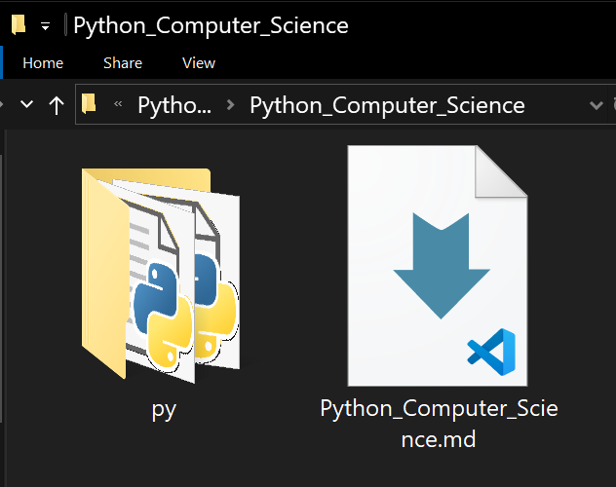

Here is our project folder.

We have our Python_Computer_Science.md file, that is our Table of Contents and it references scripts that are located in the folder named py
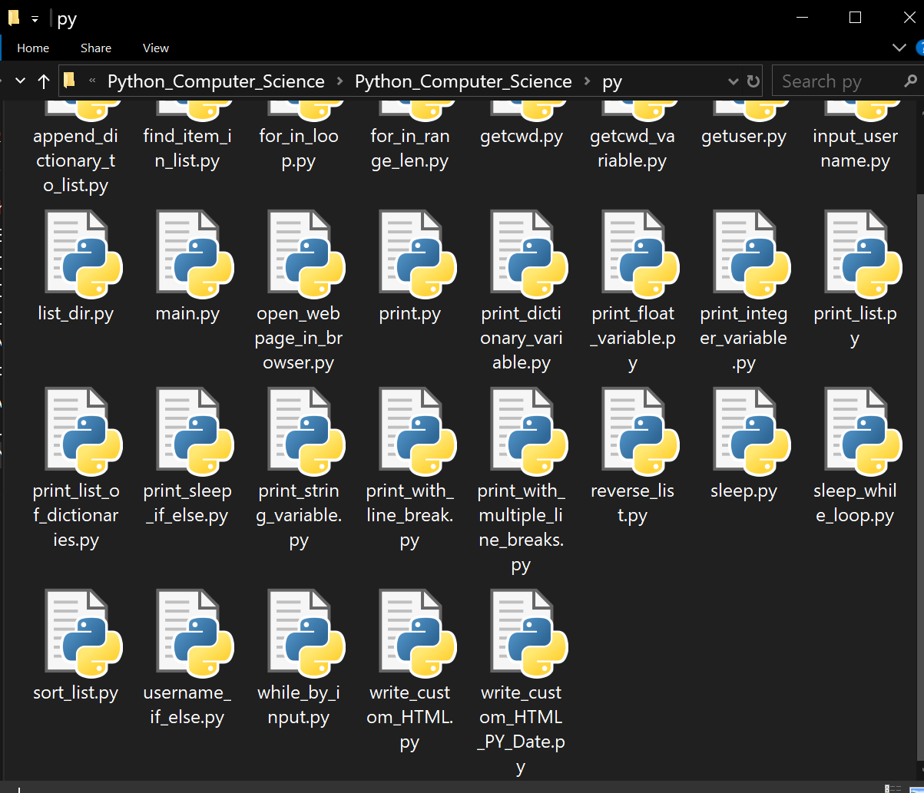
Here is our py folder of Python scripts.
Our Markdown file is located outside of the py folder.

We can open the Python_Computer_Science.md file in VSCode and use the Preview feature.

The Python_Computer_Science.md file is a Table of Contents that is clickable, but of course we must have the Python scripts in the py folder for it to reference correctly.

Important to note is that this also works on github! We can use the same reference structure so that people can have an easy time navigating our scripting project.

Happy Scripting :-)
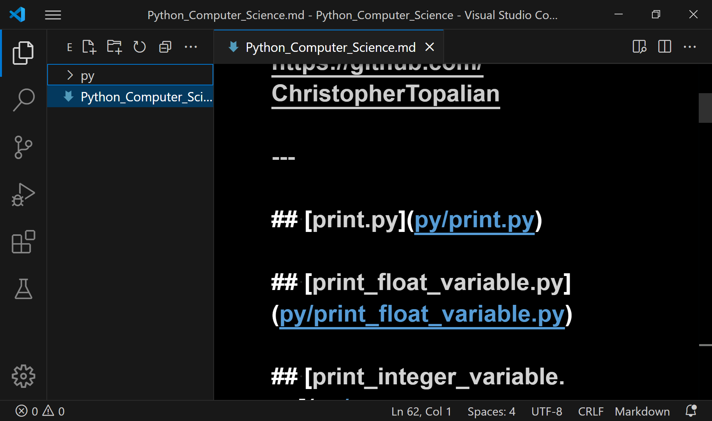
Hold Control + Left Click on any link to open a script

OR Left click on the Preview Icon at the top right of the VSCode Window to enter Preview mode.
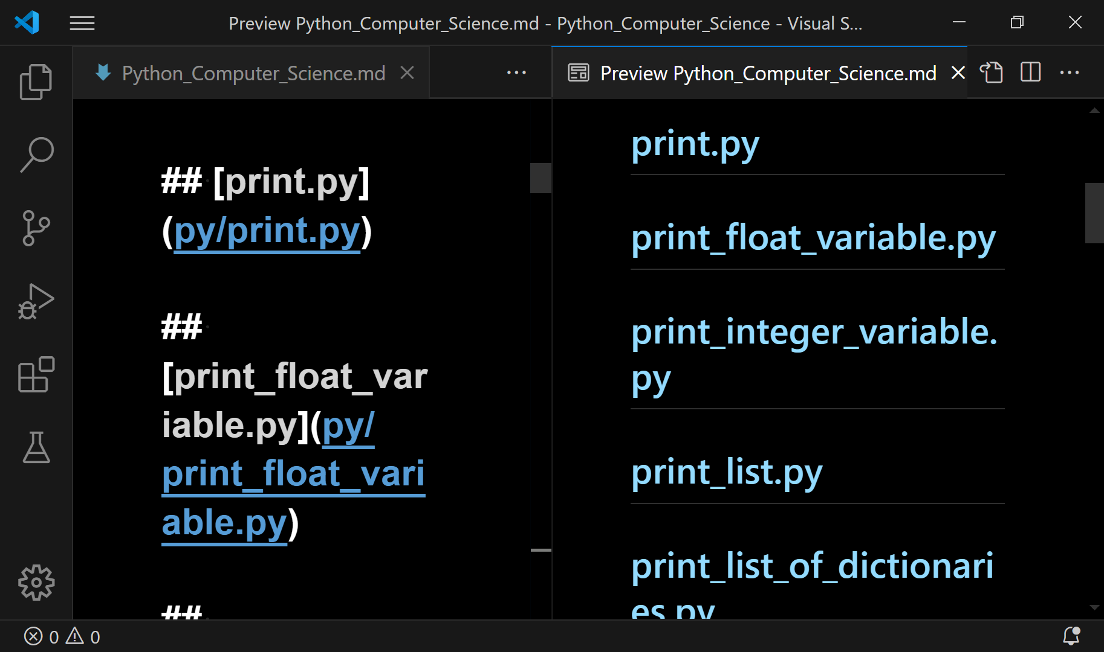
This shows our .md editable file on the left and the preview of the rendered markdown file on the right.
The right side can be left clicked on without having to hold down control.
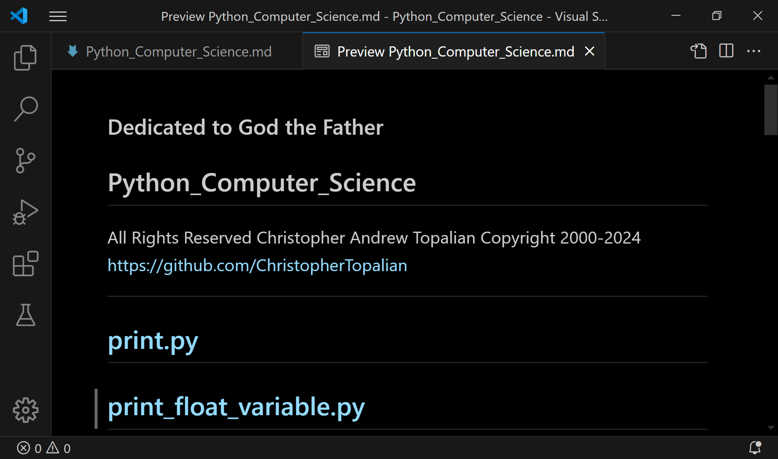
Control + Shift + V
Full Preview of our Markdown file for easy navigation in our VSCode scripting project.
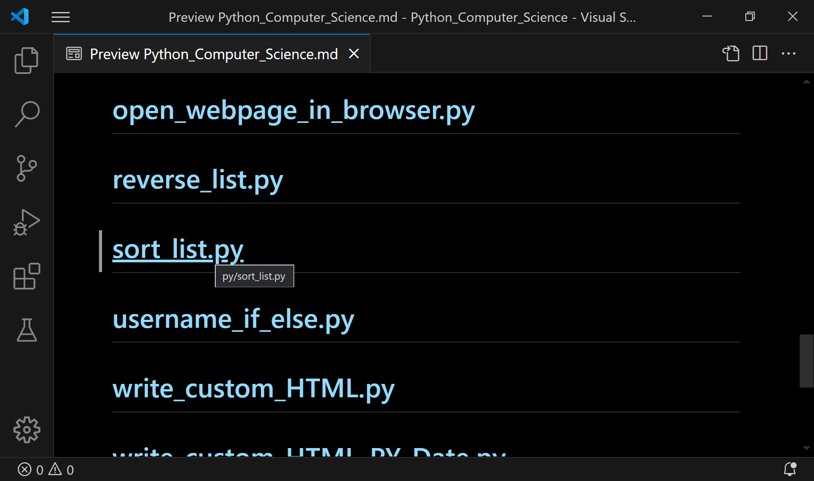
Let's say that we Left Click on the file named
sort_list.py

Result is shown on the next page.
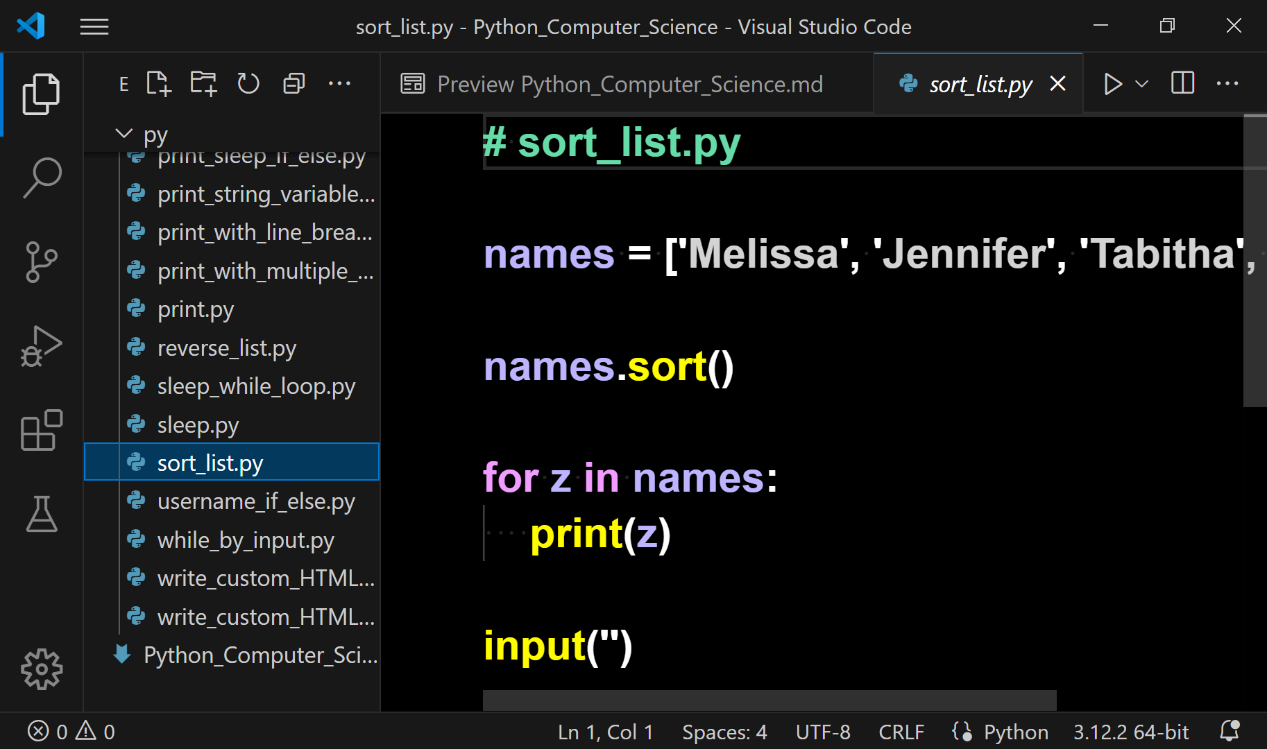
This opens our script in another tab and shows us which script in the folder is being worked on by highlighting the name of the script in the file explorer on the left side.
This makes working on big projects very easy, because we are very organized.
<!-- Python_Computer_Science.md -->

### Dedicated to God the Father

## Python_Computer_Science
All Rights Reserved Christopher Andrew Topalian Copyright 2000-2024
https://github.com/ChristopherTopalian

---

## [print.py](py/print.py)

## [print_float_variable.py](py/print_float_variable.py)

## [print_integer_variable.py](py/print_integer_variable.py)

## [print_list.py](py/print_list.py)

## [print_list_of_dictionaries.py](py/print_list_of_dictionaries.py)

## [print_dictionary_variable.py](py/print_dictionary_variable.py)

## [print_string_variable.py](py/print_string_variable.py)

## [print_with_line_break.py](py/print_with_line_break.py)

## [print_with_multiple_line_breaks.py](py/print_with_multiple_line_breaks.py)

## [sleep.py](py/sleep.py)

## [sleep_while_loop.py](py/sleep_while_loop.py)

## [while_by_input.py](py/while_by_input.py)

## [print_sleep_if_else.py](py/print_sleep_if_else.py)

## [append_dictionary_to_list](py/append_dictionary_to_list.py)

## [find_item_in_list.py](py/find_item_in_list.py)

## [for_in_loop.py](py/for_in_loop.py)

## [for_in_range_len.py](py/for_in_range_len.py)

## [getcwd.py](py/getcwd.py)

## [getcwd_variable](py/getcwd_variable.py)

## [getuser.py](py/getuser.py)

## [input_username.py](py/input_username.py)

## [list_dir.py](py/list_dir.py)

## [open_webpage_in_browser.py](py/open_webpage_in_browser.py)

## [reverse_list.py](py/reverse_list.py)

## [sort_list.py](py/sort_list.py)

## [username_if_else.py](py/username_if_else.py)

## [write_custom_HTML.py](py/write_custom_HTML.py)

## [write_custom_HTML_PY_Date.py](py/write_custom_HTML_PY_Date.py)

# append_dictionary_to_list.py

people = []

jane = {
'name': 'Jane',
'score': 98
}

people.append(jane)

print(people)
input('')

# find_item_in_list.py

ourNumbers = [
4, 875, 23, 543, 12
]

numberToFind = 875

if (numberToFind in ourNumbers):
print(f'Yes, {numberToFind} is there')
else:
print(f'No, {numberToFind} is NOT there')

input('')

# for_in_loop.py

ourNumbers = [
4, 875, 23, 543, 12
]

for z in ourNumbers:
print(z)

input('')

# for_in_range_len.py

ourNumbers = [
4, 875, 23, 543, 12
]

for z in range(len(ourNumbers)):
print(ourNumbers[z])

input('')

# getcwd.py

import os

print(os.getcwd())
input('')

# getcwd_variable.py

import os

theCwd = os.getcwd()

print(theCwd)
input('')

# getuser.py

import getpass

print(getpass.getuser())
input('')

# input_username.py

userName = input("Enter Username: ")

print("Username is: " + userName)
input('')

# list_dir.py

import os

print(os.listdir())
input('')

# open_webpage_in_browser.py

import webbrowser

webbrowser.open('https://github.com/ChristopherTopalian')

# print.py

print('Hi Everyone')
input('')

# print_dictionary_variable.py

jane = {
'name': 'Jane',
'score': 98
}

print(jane)
input('')

# print_float_variable.py

numberOfPeople = 20.82

print(numberOfPeople)
input('')

# print_integer_variable.py

numberOfPeople = 20

print(numberOfPeople)
input('')

# print_list.py

people = [
'Jane',
'Tabitha',
'Melissa'
]

print(people)
input('')

# print_list_of_dictionaries.py

people = [
{
'name': 'Jane',
'score': 95
},
{
'name': 'Melissa',
'score': 98
},
{
'name': 'Tabitha',
'score': 93
},

]

print(people)
input('')

# print_sleep_if_else.py

import time

print('Hi Friend')

time.sleep(3.0)

print('Is the sun shining?')

sunShining = input('y/n\n')

if (sunShining == 'y'):
print('Nice that it is sunny out')
else:
print('The sun will be there soon')

input('')
# print_string_variable.py

numberOfPeople = 'Twenty'

print(numberOfPeople)
input('')

# print_with_line_break.py

print('Hi Everyone\nHappy Scripting')
input('')

# print_with_multiple_line_breaks.py

print('Hi Everyone\n\nHappy Scripting')
input('')

# reverse_list.py

names = ['Jane', 'Jennifer', 'Melissa', 'Tabitha']

names.reverse()

for z in names:
print(z)

input('')

# sleep.py

import time

time.sleep(4.0)

print('4 seconds passed')
input('')

# sleep_while_loop.py

import time

x = 0

while x != 1:
time.sleep(4.0)
print('4 seconds passed')

input('')

# sort_list.py

names = ['Melissa', 'Jennifer', 'Tabitha', 'Jane']

names.sort()

for z in names:
print(z)

input('')
# username_if_else.py

userName = input("Enter Username: ")

if (userName == 'Christopher'):
print('Hi Christopher')
else:
print(f'Hi {userName}. Tell Christopher to sign in.')

input('')

# while_by_input.py

import time

x = input('Type 1 and press Enter\n')

while (x == '1'):
time.sleep(4.0)
print('4 seconds passed')

input('')

# write_custom_HTML.py

ourHTMLContent = """
<html>
<head>
<title> Our HTML Page </title>

<style>

body
{
padding: 10px;
background-color: rgb(30, 30, 30);
font-family: Arial;
font-size: 20px;
color: rgb(255, 255, 255);
}

</style>

</head>

<body>

<div> Hi Everyone </div>

</body>

</html>

"""

with open('ourNewWebpage.html', 'w') as theFile:
theFile.write(ourHTMLContent)

# write_custom_HTML_PY_Date.py

import datetime as dt

currentDate = dt.datetime.now().strftime('%Y-%m-%d')

ourHTMLContent = f"""
<html>
<head>
<title> Our HTML Page </title>

<style>

body {{
padding: 10px;
background-color: rgb(30, 30, 30);
font-family: Arial;
font-size: 20px;
color: rgb(255, 255, 255);
}}

</style>

</head>

<body>

<div> Current Date: {currentDate} </div>

<div> Hi Everyone </div>

</body>

</html>

"""

with open('ourNewWebpage.html', 'w') as theFile:
theFile.write(ourHTMLContent)

True Artificial Intelligence System
Tautology
1111
Contra-
-diction
0000
XOR
0110
XNOR
1001
AND
0001
NAND
1110
OR
0111
NOR
1000
MI
1101
MNI
0010
LP
0011
LC
1100
RP
0101
RC
1010
CI
1011
CNI
0100
16-Gon
For More Tutorials:

GitHub.com/ChristopherTopalian
GitHub.com/ChristopherAndrewTopalian
Sites.google.com/view/CollegeOfScripting
CollegeOfScripting.weebly.com
CollegeOfScripting.wordpress.com
Youtube.com/ScriptingCollege
Twitter.com/CollegeOfScript
Rumble.com/user/CollegeOfScripting
Dedicated to God the Father
This book is created by the
College of Scripting Music & Science.
Always remember, that each time you write a script with a pencil and paper, it becomes imprinted so deeply in memory that the material and methods are learned extremely well.

When you Type the scripts, the same is true. The more you type and write out the scripts by keyboard or pencil and paper, the more you will learn programming!

Write and Type every example that you find.
Keep all of your scripts organized.
Every script that you create increases your programming abilities.
SEEING CODE, is one thing,
but WRITING CODE is another.
Write it, Type it, Speak it, See it, Dream it.
CollegeOfScripting.weebly.com

